CASE STUDY ANALYSIS REPORT
Software Engineering — CO1 Assessment (AT-1)
AI-Based Road Surface Damage Detection and Maintenance Planning System

Name: | P SOMA SHANKAR REDDY
Register No.: | 192465066
Department: | Computer Science Engineering Cyber Security
Institution: | Saveetha School of Engineering, SIMATS
Course: | CSA1013 - Software Engineering
Assignment: | Case Study Analysis (CO1_AT-1)
Problem No.: | 17 — AI-Based Road Surface Damage Detection and Maintenance Planning System
Date: | 20 July 2026

1. Problem Understanding

1.1 Problem Explanation
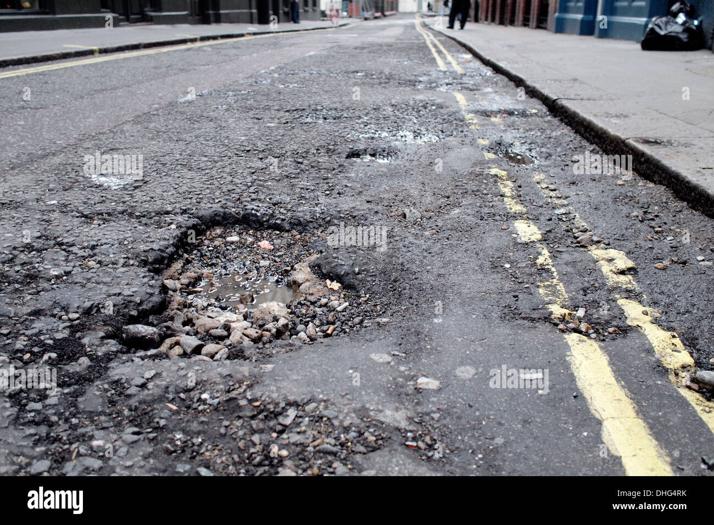
India's road network deteriorates continuously due to heavy traffic loads, monsoon rains, temperature variation, and ageing pavement. Cracks, potholes, and surface erosion appear steadily, and if these defects are not identified and repaired in time, they lead to road accidents, vehicle damage, and heavy long-term repair costs. Currently, road authorities depend on manual inspection teams that walk or drive along roads and note down defects on paper or spreadsheets. This process is slow, subjective, costly, and cannot be carried out frequently across an entire city or highway network.

The proposed system replaces this manual process with an AI-based platform that automatically analyses images captured by handheld cameras or drones, detects and classifies road defects such as potholes and cracks, estimates how severe each defect is, and plots every defect on a GIS (Geographic Information System) map. Using this map, the system prioritises which roads need urgent repair and generates a maintenance schedule for the maintenance department, thereby making road upkeep faster, more accurate, and less expensive.

1.2 Objectives of the Proposed System
- Automatically detect road surface defects from images or drone footage using AI/computer vision.
- Classify defects accurately into categories such as potholes and different types of pavement cracks.
- Estimate the severity of each detected defect (minor, moderate, severe).
- Generate GIS-based maps that visually plot the location and condition of every road segment.
- Automatically prioritise and schedule repair activities based on severity and traffic importance.
- Continuously monitor road condition over time to track deterioration or improvement.
- Produce infrastructure health reports for municipal and highway authorities.
- Significantly reduce the cost and time required for manual road inspection.

1.3 Scope of the Problem
The scope of the system covers urban and highway road networks under the jurisdiction of municipal corporations, highway authorities, and public works departments. It includes image/video acquisition from cameras mounted on vehicles or drones, AI-based defect detection and classification, severity scoring, GIS mapping, maintenance prioritisation, and reporting dashboards for decision-makers. The system is intended to support not fully replace human engineering judgement; final repair decisions and on-site verification remain with qualified civil engineers. It does not cover the actual physical repair work, procurement of materials, or heavy construction machinery operations, which remain outside the software's boundary.

2. Key Stakeholders and Challenges
Successful deployment of the proposed system depends on the coordinated participation of several stakeholder groups, each with distinct responsibilities and concerns. The table below summarises the primary stakeholders identified for this system.
Table 1: Stakeholder Analysis for the Proposed System
Stakeholder | Role / Responsibility | Key Challenges Faced
Municipal / Highway Authority | Owns and funds the road network; approves budgets and sets repair priorities. | Limited budget, huge road network to cover, and pressure to act quickly on safety complaints.
Road Maintenance Contractors | Carry out physical repair work assigned through the maintenance schedule. | Unclear or delayed information about which roads/segments genuinely need urgent repair.
Drone / Camera Field Operators | Capture road images/videos for the AI system to analyse. | Weather constraints, drone flight regulations, and coverage of remote or traffic-heavy roads.
AI / Software Development Team | Build, train, and maintain the detection, GIS, and scheduling modules. | Need for large, well-labelled datasets and continuous model retraining for accuracy.
GIS Analysts / Data Scientists | Maintain the mapping layer and validate severity-scoring models. | Integrating diverse data sources (satellite, drone, vehicle cameras) into one consistent map.
Citizens / Commuters | Report defects, use safer roads, and are directly affected by delays. | Limited channels to report issues and no visibility into repair timelines.
Government Policy Makers | Set transportation policy and allocate long-term infrastructure funding. | Balancing infrastructure spending against other public priorities.

3. Analyze the Current Approach

3.1 Existing System / Current Process
At present, most municipal and highway authorities rely on manual road inspection. Trained inspectors either walk along road stretches or travel in slow-moving vehicles, visually identifying potholes and cracks, and recording their observations on paper forms or basic spreadsheets. Some agencies have started using simple mobile apps where inspectors log GPS coordinates and a photograph, but the defect classification, severity assessment, and repair prioritisation still depend entirely on the inspector's personal judgement.

3.2 Strengths of the Current System
- Human inspectors can use contextual judgement (e.g., recognising a defect near a school as more urgent).
- No dependency on specialised hardware, AI models, or high-bandwidth connectivity.
- Simple to understand and requires minimal technical training for field staff.

3.3 Limitations of the Current System
- Extremely labour-intensive and slow — large road networks cannot be surveyed frequently.
- Subjective severity ratings vary from inspector to inspector, leading to inconsistent prioritisation.
- No centralised, real-time visual record of road condition across the entire network.
- High recurring cost of deploying inspection teams repeatedly.
- Delayed detection of defects allows minor cracks to worsen into large, costly potholes.
- Difficult to track how a defect changes over time without a systematic digital record.

3.4 Gaps That Need to be Addressed
The core gap in the current process is the absence of an objective, automated, and continuously updated record of road condition. There is no standard way to compare the urgency of defects across different roads, no predictive capability to anticipate where damage is likely to worsen, and no direct link between inspection data and maintenance scheduling. These gaps are precisely what the proposed AI-based system is designed to close.

4. Proposed Solution Using Software Engineering Principles

4.1 Solution Overview
The proposed solution is a modular, cloud-connected software platform that automates the entire road-inspection-to-maintenance-scheduling workflow. Images captured by vehicle-mounted cameras or drones are uploaded to the system, where a computer-vision model detects and classifies defects, a severity-estimation module scores each defect, and a GIS engine maps every defect geographically. A scheduling module then converts this information into a prioritised, actionable maintenance plan visible to municipal authorities and field crews through a dashboard.

4.2 Major Functional Modules
- Image Acquisition Module — captures and uploads images/video from cameras and drones.
- Preprocessing Module — cleans, resizes, and enhances images before analysis.
- AI Detection & Classification Module — a CNN/YOLO-based model that detects and labels defects.
- Severity Estimation Module — scores each defect by size, depth estimate, and location risk.
- GIS Mapping Module — plots defects on an interactive map using GPS metadata.
- Maintenance Prioritisation & Scheduling Module — ranks and schedules repairs automatically.
- Reporting & Analytics Dashboard — presents infrastructure health reports to authorities.
- Admin / User Management Module — manages roles, access, and field-crew accounts.
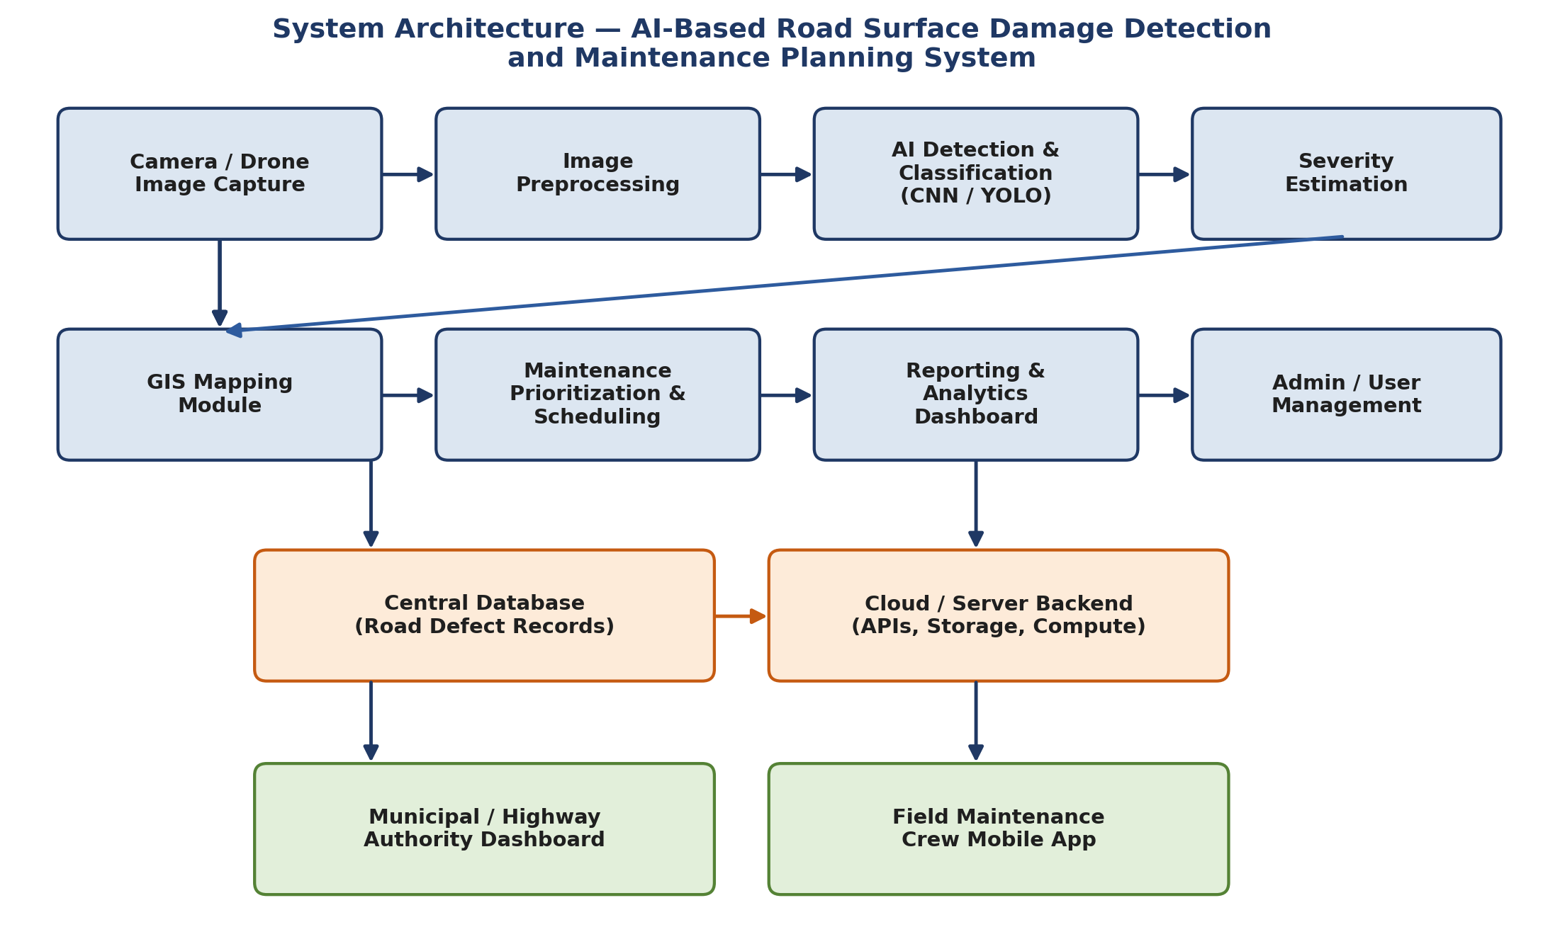
Figure 1: Proposed system architecture showing data flow from image capture through to end-user dashboards.
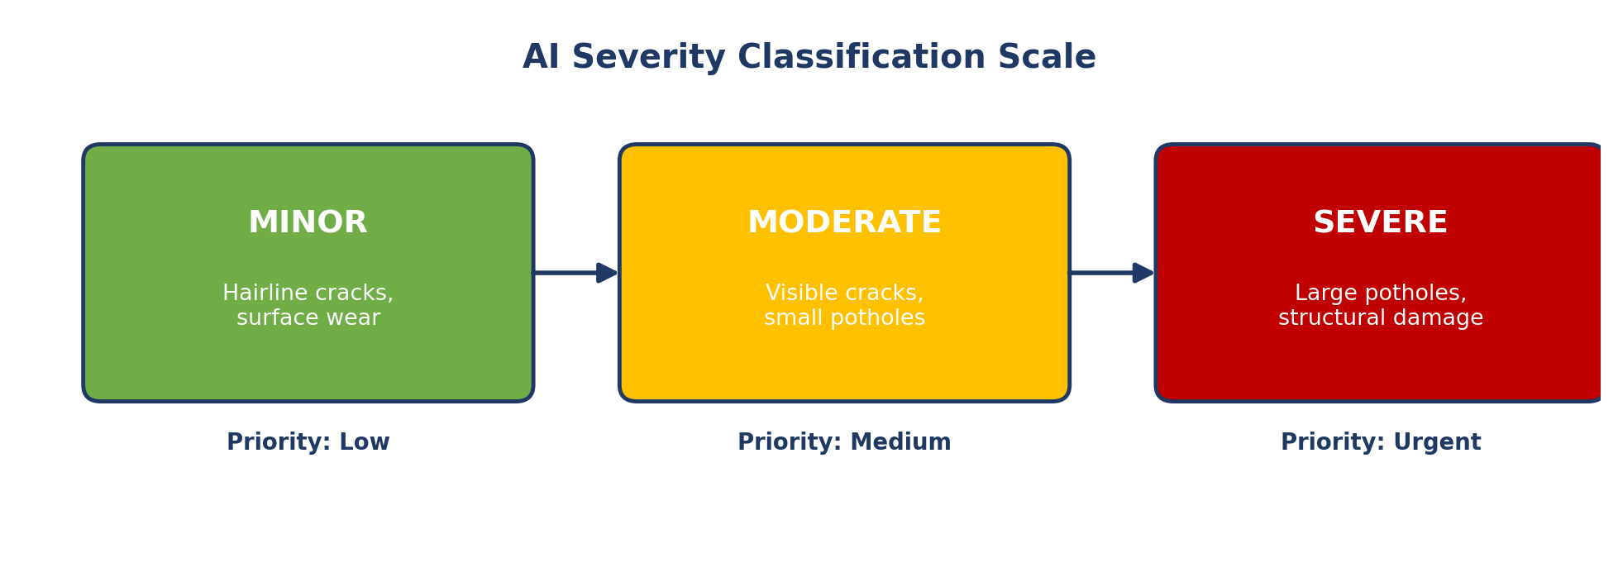
Figure 2: AI-based severity classification scale used to prioritise repairs.

4.3 Functional and Non-Functional Requirements
Table 2: Functional and Non-Functional Requirements
Type | Requirement
Functional | The system shall accept image and video input from mobile cameras and drones.
 | The system shall detect and localise road defects (potholes, cracks) within each image.
 | The system shall classify each defect by type and estimate its severity level.
 | The system shall plot every detected defect on a GIS map with its GPS coordinates.
 | The system shall generate a prioritised maintenance schedule based on severity and road importance.
 | The system shall allow authorities to generate and export infrastructure health reports.
Non-Functional | Scalability — the system must handle image data from an expanding city-wide camera/drone network.
 | Reliability — defect detection must remain consistently accurate across varied lighting and weather.
 | Usability — dashboards must be simple enough for non-technical municipal staff to operate.
 | Security — road and citizen data must be protected against unauthorised access or tampering.
 | Performance — analysis of a captured image should complete within a few seconds for near real-time use.

4.4 Application of Software Engineering Principles
- Modularity — the system is split into independent modules (detection, GIS, scheduling, reporting) that can be developed, tested, and upgraded separately.
- Scalability — cloud-based backend and containerised AI services allow the platform to expand from a single district to an entire state's road network.
- Maintainability — clear module boundaries and documented APIs make it easy to retrain models or fix defects without disturbing unrelated components.
- Reliability — redundant cloud storage and automated model-validation checks ensure consistent, dependable defect detection.
- Usability — a clean, map-centric dashboard is designed for non-technical municipal staff and field engineers.
- Security — role-based access control, encrypted data storage, and secure APIs protect sensitive location and citizen data.

5. Justification of the Chosen Methodology

5.1 Selected Framework: Agile (Scrum)
The Agile (Scrum) methodology has been selected for developing this system. Under this approach, the project is broken into short sprints of two to three weeks, each delivering a working increment of the platform — for example, one sprint may deliver the image-upload module, the next may deliver an initial defect-detection model, and a later sprint may add GIS mapping.

5.2 Why Agile Suits This Project
- The AI detection model needs repeated retraining and tuning as more labelled defect data becomes available — Agile's iterative sprints naturally accommodate this.
- Requirements from municipal stakeholders are likely to evolve once they start seeing real dashboards and maps, which Agile handles through continuous feedback.
- Frequent sprint reviews allow early detection of problems, such as poor detection accuracy in certain lighting conditions, before they affect the whole project.
- Independent modules (detection, GIS, scheduling) can be assigned to different sprint teams and integrated incrementally.

5.3 How Agile Supports Development and Maintenance
Agile's short feedback loops mean that after every sprint, the development team demonstrates working functionality to stakeholders such as municipal engineers, who can immediately request adjustments — for instance, refining how severity scores are displayed. This continuous validation reduces the risk of building a system that does not match real field needs. For long-term maintenance, Agile's culture of regular retrospectives and incremental releases makes it straightforward to schedule periodic AI model retraining sprints as new road-defect data is collected over time.
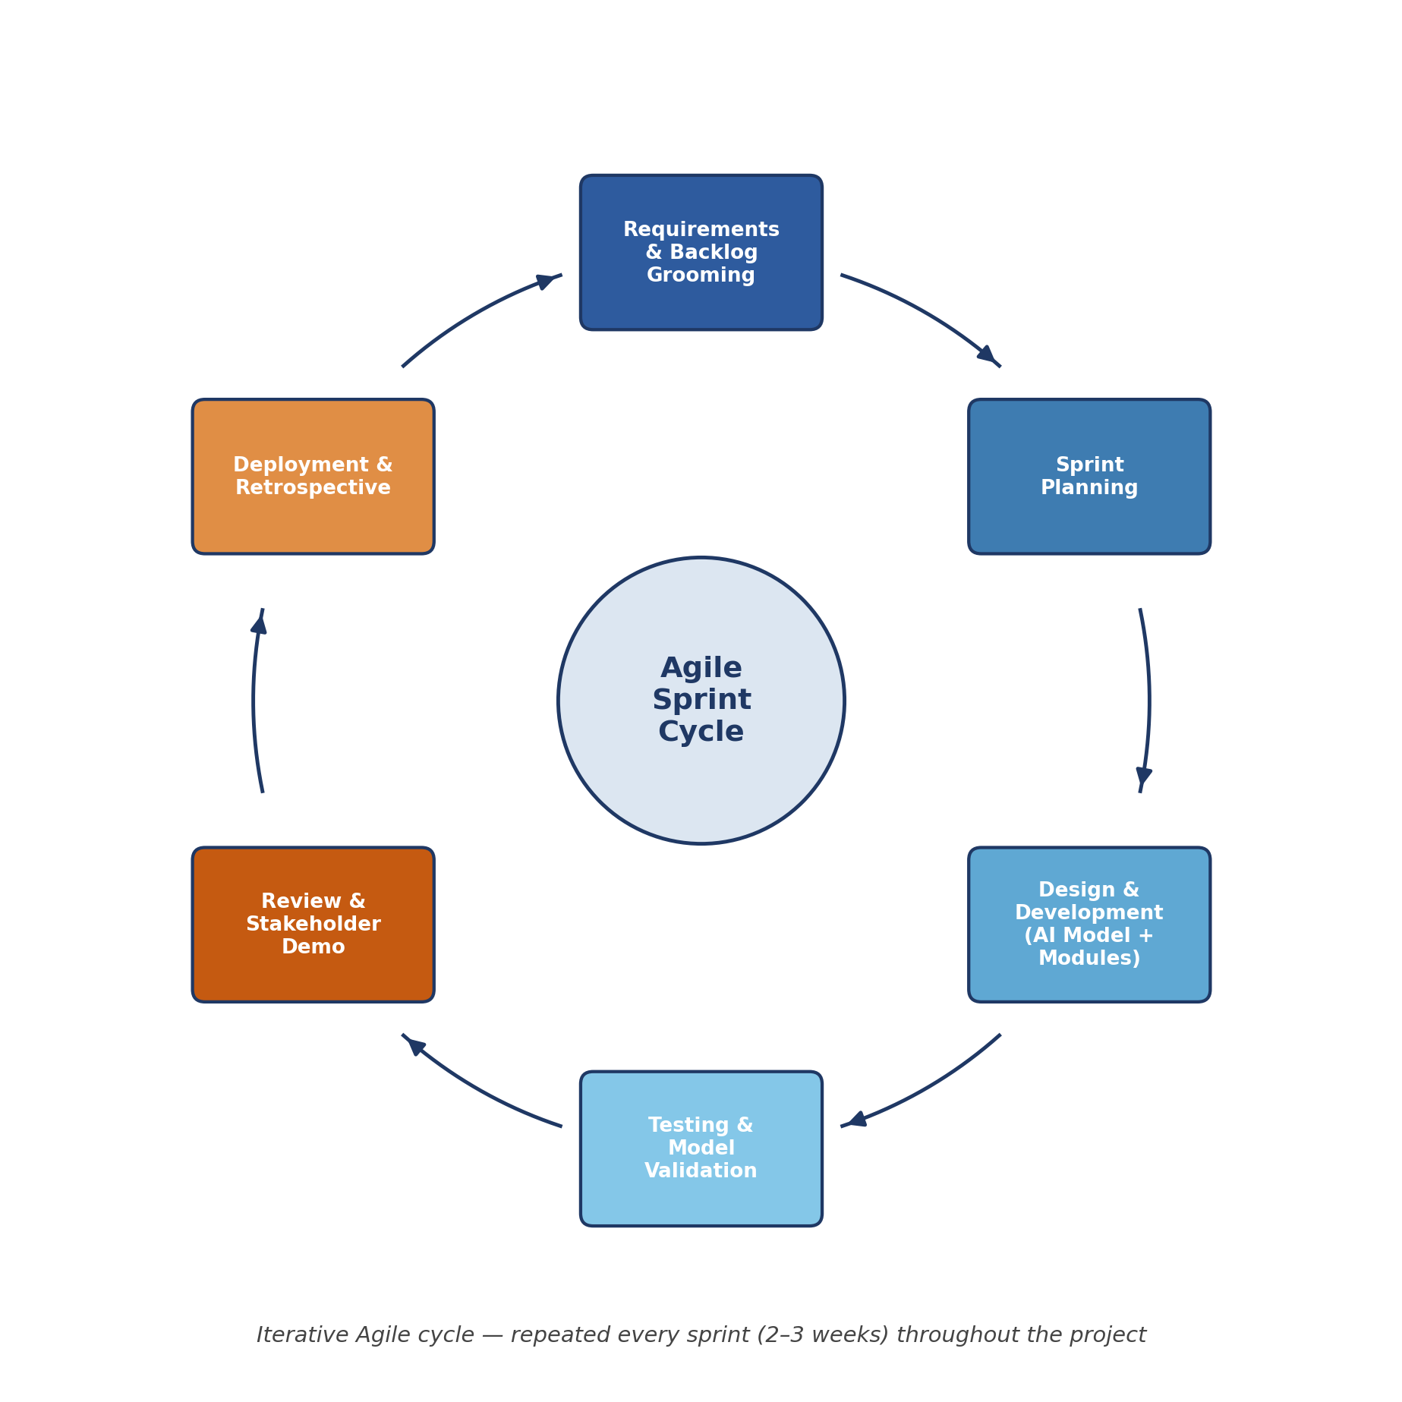
Figure 3: Agile sprint cycle followed for iterative development of the AI and GIS modules.

6. Expected Outcomes and Limitations

6.1 Expected Benefits
- Accurate, consistent, AI-driven detection of road defects, removing subjective human variation.
- Faster maintenance planning through automatically generated, prioritised repair schedules.
- Improved road safety by identifying dangerous defects before they escalate.
- Reduced overall infrastructure maintenance costs through timely, targeted repairs.
- More efficient allocation of repair crews and materials based on real data.
- Continuous, city-wide monitoring of road condition instead of periodic manual surveys.
- Higher public satisfaction as roads are repaired proactively rather than reactively.

6.2 How the Solution Addresses Identified Challenges
By automating detection and severity scoring, the system removes the inconsistency and slowness of manual inspection identified in Section 3. The GIS-based prioritisation directly solves the current lack of a centralised, comparable view of road condition, giving maintenance contractors and authorities a single, trustworthy source of truth for planning repairs.

6.3 Potential Risks and Implementation Challenges
- Data quality — poor image quality, bad weather, or dim lighting can reduce detection accuracy.
- False positives/negatives — the AI model may occasionally misclassify shadows or stains as damage, requiring periodic human verification.
- Regulatory constraints — drone flights may require government clearance and airspace permissions.
- Initial cost — deploying cameras, drones, and cloud infrastructure requires upfront investment.
- Change management — field staff and contractors need training to adapt to the new digital workflow.

6.4 Future Enhancements
- Integrating real-time video streams and IoT vibration sensors for continuous monitoring.
- Adding predictive maintenance using historical data to forecast where damage will occur next.
- Building a citizen-reporting mobile app that feeds directly into the AI verification pipeline.
- Extending the platform to detect other infrastructure issues such as faded lane markings or damaged signage.

